# Nature of, prevention of and treatments for common bunt in organic cultivation

Andy Forbes, Secretary, [Brockwell Bake Association](http://brockwell-bake.org.uk/)  
with assistance from Patrice Marchand [Institut Technique de l’Agriculture Biologique](http://www.itab.asso.fr/) and Anders Borgen <http://www.agrologica.dk/>

### Introduction

Common bunt is one of the most damaging diseases found in agriculture - and is likely to have been so since the initial domestication of wheat. Bunt spores from Mesopotamia 4000 years old having been found on grain. It is a fungus with a infection root that is closely adapted to spread itself during human wheat harvesting processes.

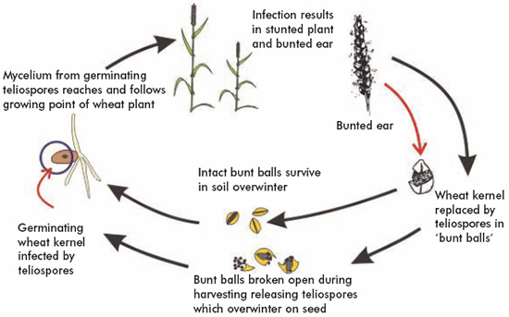

from [HGCA wheat disease](http://archive.hgca.com/minisite_manager.output/3606/3606/Cereal%20Disease%20Encyclopedia/Diseases/Bunt%20or%20Stinking%20Smut.mspx?minisiteId=26) [encyclopedia](http://www.google.com/url?q=http%3A%2F%2Farchive.hgca.com%2Fminisite_manager.output%2F3606%2F3606%2FCereal%2520Disease%2520Encyclopedia%2FDiseases%2FBunt%2520or%2520Stinking%2520Smut.mspx%3FminisiteId%3D26&sa=D&sntz=1&usg=AFQjCNEu2_nc7sBUKotZO5VapTQwPv3mtQ)

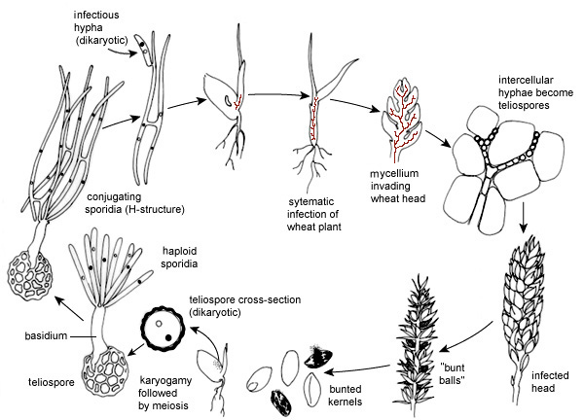

from “[Stinking smut (common bunt) of wheat](http://www.apsnet.org/edcenter/intropp/lessons/fungi/Basidiomycetes/Pages/StinkingSmut.aspx)” by Don E. Mathre, Montana State University

The common bunt fungus (Tilletia tritici syn. T. caries) grows systemically in wheat plants. In infected ears of the plant the normal grain except for the bran layers are replaced by black spores. At harvest in threshing these bunt balls burst and spores (which smell like bad fish hence the synonym "stinking smut") get onto the remaining healthy grain. The spores on the healthy grain surface germinate along with the seed. Each produces a short fungal thread terminating in a cluster of elongated cells. These then produce secondary spores which infect the [coleoptiles](http://www.hgca.com/minisite_manager.output/3700/3700/Cereal%20Disease%20Encyclopedia/Cereal%20Disease%20Encyclopedia/Glossary.mspx?minisiteId=26#C) of the young seedlings before the emergence of the first true leaves. The [mycelium](http://www.hgca.com/minisite_manager.output/3700/3700/Cereal%20Disease%20Encyclopedia/Cereal%20Disease%20Encyclopedia/Glossary.mspx?minisiteId=26#M) grows internally within the shoot infecting the developing ear. Affected plants develop apparently normally until the ear emerges when it can be seen that grain sites have been replaced by bunt balls.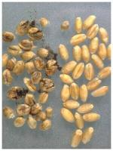

Early farmers' journals give numerous recipes for "steeps" and other methods to defend against common bunt infection. 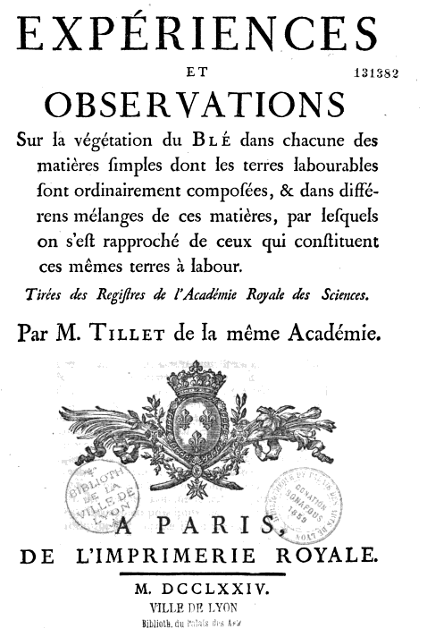

Frenchman Maurice Tillet (after whom the family of fungus concerned is named) correctly identified black powder on surface of good grain as the agent of common bunt infection in 1755.

The mechanism of infection of common bunt was identified by Frenchman Bénédict Prévost in 1807 in his report “[Memoir on the Immediate Cause of Bunt Or Smut of Wheat: And of Several Other Diseases of Plants, and on Preventives of Bunt](http://books.google.co.uk/books?id=YgxgAAAAMAAJ&pg=PA2#v=onepage&q&f=false)”. He established copper sulphate and copper acetate (vinegar left in a copper pot) as effective treatments for bunt prevention whilst proving traditional treatments such as brining, liming and arsenic were relatively ineffective.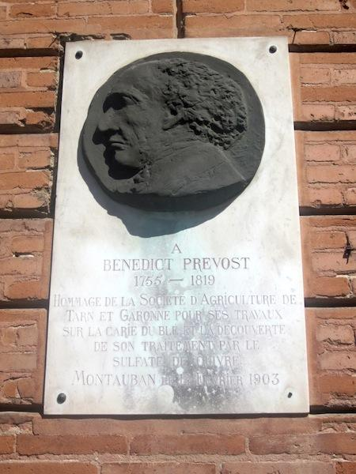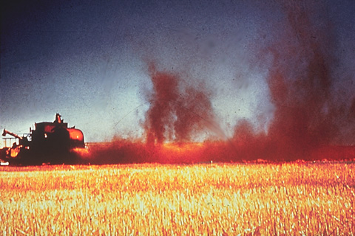

A dramatic high point in the history of bunt infection is maybe the phenomenon of clouds of bunt spores around early horse drawn combines exploding. 160 such explosions were recorded in 1930 in Washington state.

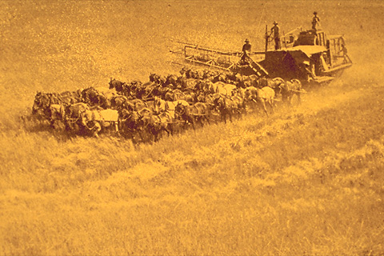

In the 1920s organic mercury seed treatment was introduced which effectively controlled common bunt and when this treatment was banned it was replaced by effective chemical fungicides. For conventional farmers therefore "common bunt" has become a forgotten disease, however for organic arable farmers the threat remains.

### Common bunt in organic wheat farming in the European Union

The best organic farming practice is to have seed tested for bunt and not to sow if infected, however where the potentially infected seed stock is all that is available there may not be an alternative. Therefore a preventive/curative treatment is a necessity.

It should be noted that although the most frequent root of infection is during harvest processing, from infected to healthy grain, bunt can spread via infected soil, this usually happens where infected grains burst before harvest usually as a result of rain falling on them - different varieties of wheat being more or less susceptible to this happening and wind blown during harvesting. Soil infection can last up to 10 years. The result is that many organic arable farms have a background level of soil infection and again preventative treatment where possible and economical is recommended particularly where one wants to save seed for re-sowing.

The number of bunt spores permitted per grain for [certified seed](http://www.fera.defra.gov.uk/plants/seeds/seedCertification/) (permissible to be sold) varies across the EU from 0 in Sweden, 1 in UK, equivalent of 2 spores per grain for organic seed in France and up to 20 spores per grain for organic seed production in Germany.

In principle organic seed must be two multiplications on from conventional treatment before being classed as organic C2 seed. However where no organic seed of a particular crop or line is available and the would be cultivator can prove no other equivalent variety organically grown is available conventionally grown seed may be sown under [EC Regulation (EEC) No. 2092/91](http://eur-lex.europa.eu/LexUriServ/LexUriServ.do?uri=CONSLEG:1991R2092:20060506:EN:PDF) (superseded by [EC Regulation No. 834/2007](http://eur-lex.europa.eu/LexUriServ/LexUriServ.do?uri=OJ:L:2007:189:0001:0023:EN:PDF)) after a derogation or “exception” appeal by the farmer concerned. The effective degree to which conventionally grown (untreated, C1) seed is allowed to enter into organic agriculture across the EU in practice varies considerably from country to country.

Most conventional seed has had a chemical seed treatment which strictly speaking precludes it from entering organic cultivation but this would seem to be flouted in some cases as very little conventional certified cereal seed is available without having been conventionally treated in several crop sectors.

Unfortunately the reliance on a degree of conventional cereal seed entering organic agriculture under derogation (“exception”) may be counter productive to ongoing organic farm seed-saving as the level of bunt infection overall in conventionally grown untreated wheat seed (C1 seed) may be higher than in C2 seed from organic seed suppliers.10

Preference for using organic seed wherever possible on the part of growers can also vary. In Denmark, most organic farmers use organically propagated cereals for seed and all seed lots are tested for infections of seed-borne pathogens before sowing. About 50% of all seed lots are discarded based on this assessment, but huge differences occur between year and crop, which makes planning of seed production virtually impossible. In some years up to 90% of the seed lots may be discarded.10

### Heritage cereal cultivation in organic farming and bunt

Progression towards 100% organic seed in EU organic farming is hampered by the small scale of the sector and the shortfall is made up by “exceptions” for the use of conventionally grown seed by individual growers. Figures for UK in 2001 were 60% “bought-in non-organic”, 20% “brought-in organic” and 20% “organic farm saved”.

In significant respects this shortfall is not simply a failure to meet a target in eliminating non-organic inputs. It also points to the reality that commercial plant breeding is overwhelmingly driven by the conventional farming sector, plant breeding is structured and shaped by high chemical, energy and mechanical inputs typical of current conventional farming. This is perhaps most clearly defined in the case of wheat and rice where in the 1960’s the “Green Revolution” ushered in a dwarfing of the vast majority of the world’s crop of these cereals specifically so as to enable the application of chemical fertilizer. The dwarfing of wheat in turn created a problem of weed control typically met with herbicides in conventional cultivation and this in turn has resulted in a problem of mono-culture in fields increasing the chances of epidemic proportion disease and pest problems to be countered in conventional farming by preventative fungicide and pesticide application.

Modern wheat breeding is overwhelmingly tailored to conventional farming and the use of high inputs which is reinforced by the “Permitted for cultivation” rules which only allow the sowing of commercial crop varieties that pass DUS (distinct, unique and stable, genetically) and VCU (Value for Cultivation and Use in conventional farming) tests. The only exception to passing DUS and VCU tests in order to be permitted for cultivation currently is [“Conservation variety” status](http://www.fera.defra.gov.uk/plants/plantVarieties/nationalListing/documents/guidelinesAgricultureConservation13.pdf).

“Heritage cereals” in UK usage, in the case of wheat, denotes pre-Green Revolution wheat early cultivars and landraces. In other countries these wheats may be referred to by other names such as “heirloom varieties” in the USA or “blé paysannes” in France. Heritage cereals in use before modern intensive farming can provide at least the starting point for making available wheats better adapted to organic farming as well as being eligible for “conservation status” as a result of implementation of [International Treaty on Plant Genetic Resources for Food and Agriculture](http://www.planttreaty.org/). From the consumer’s perspective increasing evidence is emerging from scientific trials and studies that many heritage bread wheat lines offer superior nutritional and digestive benefits compared to modern wheat lines. A number of countries in the EU and elsewhere have seen interest in and cultivation of heritage cereals blossom, including Canada, the US, France, Italy and the Nordic countries.

So far in the UK less than 30 hectares of heritage wheat for milling per annum (2014) is in cultivation but a number of organizations are in the process of bulking up from genebank accessions potentially interesting British Isles regional heritage wheats. This includes Goldendrop and Rouge d’Ecosse with the “[Scotland the Bread](http://www.breadmatters.com/index.php?route=information/information&information_id=16)” project, Hen Gymro with the [Welsh Grain Forum](http://welshgrainforum.co.uk/) and Red Lammas, Kent Old Red and Kent Old Hoary with the [Brockwell Bake Association](http://www.brockwell-bake.org.uk/) in South East England.

However the nature of the interest in heritage cereals, which is effectively confined to organic farming, means that there are no conventionally grown and treated seed stocks of these heritage lines of any commercial scale to fall back on in the case of common bunt infection (or other crop failures). At the same time if UK heritage cereals follows a similar pattern in their reintroduction to cultivation as elsewhere i.e. predominantly by associations of smaller scale organic growers with little capital or resources, often sharing and swapping seed for evaluation without certification, there is precisely a real danger of common bunt infection in seed stocks spreading and this has indeed created problems in France, Italy and the Nordic countries.

### Possible non-chemical treatments for common bunt

One day it is possible resistance to common bunt will be bred into wheat. Work on this is ongoing, though limited in scale since the advent of effective chemical control in conventional farming. This work is reviewed in some depth in [Control of Common Bunt in Organic Wheat](http://apsjournals.apsnet.org/doi/pdf/10.1094/PDIS-09-10-0620). However this hasn’t happened yet and so other strategies are needed for the time being.

There are more than a few remedies against common bunt that are effective, if not as effective as modern chemical treatments, both historical and more modern. Several studies listed below review these strategies though unfortunately few consider the complete set of possibilities. One of the most complete is in French, [CAHIER TECHNIQUE Carie du Blé “Agir avant qu’il ne soit trop tard”](http://www.brockwell-bake.org.uk/docs/anti_bunt_fr.pdf) from Institut Technique de l'Agriculture Biologique, 2007, page 9. The second table on page 9 is based on the research of Anders Borgen [Strategies for Regulation of Seed Borne Diseases in Organic Farming](http://www.brockwell-bake.org.uk/docs/Strategies%20for%20Regulation%20of%20Seed%20Borne%20Diseases%20in%20Organic%20Farming.pdf). Other studies fail to include consideration of the commercial product Tillecur or vinegar because these are not currently in the EU permitted products for organic farming [Annex II](http://eur-lex.europa.eu/LexUriServ/LexUriServ.do?uri=OJ:L:2008:250:0001:0084:EN:PDF) although they may be mentioned viz. [European case study on seed treatments and seed-borne disease control using seed treatments](http://www.brockwell-bake.org.uk/docs/HGCA%20-%20European%20case%20study%20on%20seed%20treatments%20and%20seed-borne%20disease%20control%20using%20seed%20treatments.pdf).

A strategy for control of common bunt in organic wheat seed stock needs to be at once effective in keeping common bunt from destroying harvests and seed stocks and scalable in terms of resources and capital, ideally from the level of the home, allotment or community garden grower upwards.

Some of the possibilities :-

1. **Heat Treatment**  
   Humid air heat treatments have more chance of success than dry and two modern technological solutions exist [Sono-Steam](http://www.forcetechnology.com/en/Menu/Products/Sono-Steam/) (designed primarily for retail food market) and [ThermoSeed](http://seedmeetstechnology.com/en/thermoseed-incotec/) however both rely on very expensive plant.
2. **Hot water**  
   traditional hot water method where the grains are submerged in hot water is costly and complicated especially in the case of large quantities of cereals, which will require drying afterwards
3. **Irradiation**  
   Experiments in Germany. Expensive plant
4. **Brushing**  
   some good results viz. [Removal of bunt spores from wheat seed lots by brush cleaning](http://orgprints.org/3202/1/3202.pdf) but rare lab or high end seed cleaning equipment needed.
5. **Copper sulphate**  
   first proved effective by Bénédict Prévost in 1807 in his report “[Memoir on the Immediate Cause of Bunt Or Smut of Wheat: And of Several Other Diseases of Plants, and on Preventives of Bunt](http://books.google.co.uk/books?id=YgxgAAAAMAAJ&pg=PA2#v=onepage&q&f=false)” however though copper sulphate is allowed in EU permitted products for organic farming [Annex II B](http://eur-lex.europa.eu/LexUriServ/LexUriServ.do?uri=OJ:L:2008:250:0001:0084:EN:PDF) to many in organic and biodynamic farming copper is unacceptable and not an organically derived product (COPSEED).
6. **Tillecur**  
   commercial product aimed at organic market from Germany. 93% mustard powder, starch and other undisclosed ingredients. Tillecur is in the process of becoming certified for use as plant strengthening product in Germany, Austria and the Czech Republic. It has had previously temporary countrywide derogation in France in 2007 and individual farm derogations for use in UK. Very good results in trials compared to other non-chemical solutions e.g. [Investigations in the regulation of common bunt (Tilletia tritici) of winter wheat with regard to threshold values, cultivar susceptibility and non-chemical protection measures](http://www.brockwell-bake.org.uk/docs/bunt_treatment.PDF). Relatively expensive solution.
7. **Vinegar** (domestic vinegar - 5% acetic acid)  
   Simple application of small quantity of this organic food product (15ml to 30ml per IK seed) can reduce infection by up to 96% in trials ([Effect of seed treatment with organic acids on the control of common bunt (Tilletia tritici and T. laevis) in wheat](http://www.ncbi.nlm.nih.gov/pubmed/12425040) and [Effect of seed treatment with acetic acid for control of seed borne diseases](http://www.brockwell-bake.org.uk/docs/Effect%20of%20seed%20treatment%20with%20acetic%20acid%20for%20control%20of%20seed%20borne%20diseases.pdf)) which if used preventatively should be adequate to protect against catastrophic infection that might require other treatments. Some question remains whether vinegar and/or acetic acid at various concentrations aids germination and/or protects against fungal infection.
8. **Biological**  
   Various treatments have been developed. [Cerall](http://www.bioagri.se/?p=30838) and [Cedomon](http://www.bioagri.se/?p=30922&m=4373&topic=cedomon_) are biopesticides containing soil-dwelling bacterium *Pseudomonas chlororaphis* strain 342 approved for organic use in EU. It comes in 200 L or 1000 L packs which are not resealable, to be applied at 10 L or 7.5 L per tonne so is not suitable for small batches. Cost in Finland seems acceptable but needs to be temperature controlled during delivery to user. Some questions remain about effect on soil microflora balance and some trials show noticeable variability of efficacy season to season.
9. **Milk powder**In trials [Use of mustard flour and milk powder to control common bunt (Tilletia triticil in wheat and stem smut (Urocystis occulta) in rye in organic agriculture](http://www.agrologica.dk/publikationer/milkpowder2001.pdf) milk powder was fairly effective at doses between 43g/1K seed and 80g/1K seed however some adverse effect on germination.
10. **Mustard powder**In trials [Use of mustard flour and milk powder to control common bunt (Tilletia tritici in wheat and stem smut (Urocystis occulta) in rye in organic agriculture](http://www.agrologica.dk/publikationer/milkpowder2001.pdf) mustard powder dose of 10g/1K was effective but doses of over 30g/1K adversely affected germination.
11. **Early sowing**  
    Late sowing at cooler (5-15°C) temperatures resulting in slow germination allows more time for the common bunt spore to penetrate the [coleoptiles](http://www.hgca.com/minisite_manager.output/3700/3700/Cereal%20Disease%20Encyclopedia/Cereal%20Disease%20Encyclopedia/Glossary.mspx?minisiteId=26#C) of young seedlings before the emergence of first true leaf thus early sowing is beneficial.

### Summary

A common bunt infection of a seed stock is estimated to increase season on season at between 100% and 1000% without intervention. Initial infection can easily be missed without testing, especially in mechanical harvesting. The best run operations can fall foul of common bunt, in 2011 the UK’s Organic Research Centre experienced such a crisis in their wheat trials viz. [ORC bulletin 107](https://drive.google.com/file/d/0B8HLeOcBswPbSmVJZDRKamhHZ0E/view) since when they have commonly used the Tillecur treatment.

The need to trial and test means of controlling common bunt hand in hand with increasing usage of organic seed in organic farming has been advised by numerous studies conducted within the EU and elsewhere. In so far this has been done at all, relevant products or strategies have not so far been commonly certified for organic use. In the case of local heritage varieties of wheat this has potentially disastrous consequences in the form of the threat of the loss of unique seed stocks and thus loss of genetic biodiversity in a main food crop.

In the context of the preservation and cultivation of heritage wheat seed stocks solutions need to be easily and consistently applicable down to the amateur grower level. Preventative treatment would be best in the absence of testing (often prohibitively expensive for multiple lines in small operations) and where harvesting and crop processing is often done with and in hard to sanitise DIY equipment and environments. All associations involved in heritage cereal cultivation should organise education amongst their members to alert to them to the risk of common bunt infection and stipulate seed swapped among members is treated even when seed is thought to be bunt free.

Vinegar and mustard powder as products that are easily obtainable in organic (non-synthetic and certified organically produced) form and which are non-hazardous in conventional usage quantities would seem to be the most suitable candidates as the first line of protection against common bunt (see Appendix 1 for progress here). Restrictions on level of application per hectare might be applicable.

Tillecur is well tested and in some EU countries is already in the process of becoming certified for organic use as a “plant strengthener” on the basis of its mustard powder base and would be good to have certified more widely.

For larger scale growers [Cerall](http://www.bioagri.se/?p=30838) and [Cedomon](http://www.bioagri.se/?p=30922&m=4373&topic=cedomon_) biological products look promising if delivery from Sweden can be organised.

### Appendix I

## ITAB (France) submission of dossier to EC for recognition of vinegar as a plant protection product (PPP)

The French [Institut Technique de l'Agriculture Biologique](http://fr.wikipedia.org/wiki/Institut_technique_de_l%27agriculture_biologique) ran a programme “[Agir rapidement pour contenir la carie commune](http://www.itab.asso.fr/programmes/carie-ble.php)” from 2008 to 2012 including education + studies and trials of strategies for protection against common bunt. From these trials the efficacy of vinegar as a treatment against common bunt was verified as outlined here [Utilisation de l’acide acétique (vinaigre) dans la lutte contre la carie du blé (Tilletia caries et foetida)](http://www.brockwell-bake.org.uk/docs/Utilisation%20de%20l%E2%80%99acide%20ac%C3%A9tique%20(vinaigre)%20dans%20la%20lutte%20contre%20la%20carie%20du%20bl%C3%A9%20(Tilletia%20caries%20et%20foetida).pdf).

## General regulation approval

As a result ITAB has facilitated at a [conference in April 2013](http://www.itab.asso.fr/downloads/actes%20suite/resumes-intrants-web.pdf) in Paris the submission to the EC of a dossier applying for recognition of vinegar (food grade) as a "basic substance" (Art. 23) [[Basic Substance Application (BSA)]](http://www.efsa.europa.eu/fr/supporting/pub/641e.htm) that can then be used for plant protection (but not marketed as such, Art. 28) according to Regulation [(EC) No 1107/2009](http://eur-lex.europa.eu/LexUriServ/LexUriServ.do?uri=OJ:L:2009:309:0001:0050:EN:PDF) (procedure [SANCO/10363/2012](http://ec.europa.eu/food/plant/pesticides/approval_active_substances/docs/working_document_10363_2012_en.pdf) rev.9). The amended dossier submitted can be read here [BSA Vinegar February 2014](http://www.researchgate.net/publication/260591289_BSA_Vinegar_February_2014). Since regulatory delay stipulated in Sanco Document is 6 months between [EFSA](http://www.efsa.europa.eu/) outcome and place to vote, vote at [SCOFCAH](http://ec.europa.eu/food/plant/standing_committees/sc_phytopharmaceuticals/index_en.htm) (DGSanco) is expected during the first quarter of 2015 since [EFSA](http://www.efsa.europa.eu/) report ([EN-641](http://www.efsa.europa.eu/en/supporting/doc/641e.pdf)) was delivered July 31th 2014.

## Transfer to OF (Organic Farming)

This is apparently a necessary preliminary [measure](http://www.sinab.it/share/img_lib_files/2057_dossier_concerning_the_request_to_amend_annex_ii.pdf) to getting vinegar included in Annex II of [REGULATION (EC) No 889/2008](http://eur-lex.europa.eu/LexUriServ/LexUriServ.do?uri=OJ:L:2008:250:0001:0084:EN:PDF) to be permitted for plant protection in EU organic farming after examination by [EGTOP](http://ec.europa.eu/agriculture/organic/eu-policy/expert-advice/index_en.htm) and vote at [RCOP](http://ec.europa.eu/agriculture/committees/organic_en.htm) (DGAgri). The general question of the transfer of the approved basic substances to OF is due to be discussed by [RCOP](http://ec.europa.eu/agriculture/committees/organic_en.htm) 25th Nov. 2014 in Brussels (however this item on agenda was not reached). Further discussions September 2015 with a vote due December 2nd/3rd 2015 with implementation anticipated MArch 2016.

### Sources and further reading

1. [Control of Common Bunt in Organic Wheat](http://apsjournals.apsnet.org/doi/pdf/10.1094/PDIS-09-10-0620) authors J. B. Matanguihan and K. M. Murphy, Washington State University, Pullman; and S. S. Jones, Washington State University, Mount Vernon
2. [Investigations in the regulation of common bunt (Tilletia tritici) of winter wheat with regard to threshold values, cultivar susceptibility and non-chemical protection measures](http://www.brockwell-bake.org.uk/docs/bunt_treatment.PDF) authors F. Waldow & M. Jahn
3. [Effect of seed treatment with organic acids on the control of common bunt (Tilletia tritici and T. laevis) in wheat.](http://www.brockwell-bake.org.uk/docs/Effect%20of%20seed%20treatment%20with%20organic%20acids%20on%20the%20control%20of%20common%20bunt%20(Tilletia%20tritici%20and%20T.%20laevis)%20in%20wheat.pdf) authors [Saidi B](http://www.ncbi.nlm.nih.gov/pubmed?term=Saidi%20B%5BAuthor%5D&cauthor=true&cauthor_uid=12425040), [Azmeh F](http://www.ncbi.nlm.nih.gov/pubmed?term=Azmeh%20F%5BAuthor%5D&cauthor=true&cauthor_uid=12425040), [Mamluk OF](http://www.ncbi.nlm.nih.gov/pubmed?term=Mamluk%20OF%5BAuthor%5D&cauthor=true&cauthor_uid=12425040), [Sikora RA](http://www.ncbi.nlm.nih.gov/pubmed?term=Sikora%20RA%5BAuthor%5D&cauthor=true&cauthor_uid=12425040). 2001
4. [Bunt and Smut Diseases of Wheat_Concepts and Methods of Disease Management.pdf](http://www.brockwell-bake.org.uk/docs/Bunt%20and%20Smut%20Diseases%20of%20Wheat_Concepts%20and%20Methods%20of%20Disease%20Management.pdf) CYMMT
5. [Geographic Distribution of Common and Dwarf Bunt Resistance in Landraces of Triticum aestivum subsp. aestivum](http://www.brockwell-bake.org.uk/docs/Geographic%20Distribution%20of%20Common%20and%20Dwarf%20Bunt%20Resistance.pdf) authors J. Michael Bonman,* Harold E. Bockelman, Blair J. Goates, Don E. Obert, Patrick E. McGuire, Calvin O. Qualset, and Robert J. Hijmans, 2006
6. [CAHIER TECHNIQUE Carie du Blé “Agir avant qu’il ne soit trop tard”](http://www.brockwell-bake.org.uk/docs/anti_bunt_fr.pdf) Institut Technique de l'Agriculture Biologique, 2007
7. [Production of organic seed in UK - final report project OF 0154](http://www.brockwell-bake.org.uk/docs/Production%20of%20organic%20seed%20in%20UK%20-%20report%202000.pdf) MAFF - Scientific report by the Organic Research Centre, 2000
8. [Organic Seed Production and Plant Breeding – strategies, problems and perspectives –](http://orgprints.org/6633/1/proceedings_berlin_symposium.pdf) Proceedings of ECO-PB 1rst International symposium on organic seed production and plant breeding, Berlin, Germany 21-22 November 2002
9. [The organic seed regulations framework in Europe – current status and recommendations for future development](http://www.brockwell-bake.org.uk/docs/The%20organic%20seed%20regulations%20framework%20in%20Europe%20%E2%80%93%20current%20status%20and%20recommendations%20for%20future%20development.pdf) authors Thomas F. Döring, Riccardo Bocci, Roger Hitchings, Sally Howlett, Edith Lammerts van Bueren, Marco Pautasso, Maaike Raaijmakers, Frederic Rey, Anke Stubsgaard, Manfred Weinhappel, Klaus P. Wilbois, Louisa R. Winkler, Martin S. Wolfe
10. [European case study on seed treatments and seed-borne disease control using seed treatments](http://www.brockwell-bake.org.uk/docs/HGCA%20-%20European%20case%20study%20on%20seed%20treatments%20and%20seed-borne%20disease%20control%20using%20seed%20treatments.pdf) authors Bill Clark and Valerie Cockerill, 2008
11. [Stinking smut (common bunt) of wheat](http://www.apsnet.org/edcenter/intropp/lessons/fungi/Basidiomycetes/Pages/StinkingSmut.aspx) author Don E. Mathre, Montana State University, 2005
12. [Survey of seed-borne pathogens in certified and farm-saved cereal seed in Britain between 1992 and 1994](http://www.hgca.com/media/373535/project_report_124.pdf) authors V Cockerell and W J Rennie, SASA, 1996
13. [Cereal varieties for organic production: Developing a participatory approach to seed production and varietal selection](http://www.brockwell-bake.org.uk/docs/Cereal%20varieties%20for%20organic%20production-%20Developing%20a%20participatory%20approach%20to%20seed%20production%20and%20varietal%20selection.pdf) DEFRA project OF0330 - final report by the Organic Research Centre, 2006
14. [REVIEW OF POTENTIAL SEED TREATMENTS FOR USE IN ORGANIC CEREALS](http://www.brockwell-bake.org.uk/docs/REVIEW%20OF%20POTENTIAL%20SEED%20TREATMENTS%20FOR%20USE%20IN%20ORGANIC%20CEREALS.pdf) DEFRA project, OF0330 Annex 9 - author, John Clarkson, 2002
15. [Organic seed treatment to control common bunt (Tilletia tritici) in wheat](http://www.agrologica.dk/publikationer/ISTA-bulletin.pdf) author Anders Borgen, 2006
16. [Effect of seed treatment with acetic acid for control of seed borne diseases](http://www.brockwell-bake.org.uk/docs/Effect%20of%20seed%20treatment%20with%20acetic%20acid%20for%20control%20of%20seed%20borne%20diseases.pdf) authors Anders Borgen, B J Nielsen, 2001
17. [Biological Control of Common Bunt (Tilletia tritici)](http://www.agrologica.dk/publikationer/biological_control2000.pdf) authors Anders Borgen, Mehrnaz Davanlou, 2000
18. [Removal of bunt spores from wheat seed lots by brush cleaning](http://orgprints.org/3202/1/3202.pdf) author Anders Borgen, 2005
19. [Use of mustard flour and milk powder to control common bunt (Tilletia triticil in wheat and stem smut (Urocystis occulta) in rye in organic agriculture](http://www.agrologica.dk/publikationer/milkpowder2001.pdf) authors A Borgen, L Kristensen, 2001
20. [Threshold levels for seed borne diseases in organic cereals](http://www.darcof.dk/enews/sep04/threshold.html) author [Bent J. Nielsen](http://www.agrsci.org/afdelinger/forskningsafdelinger/plb/medarbejdere/bjn) 2004
21. [Strategies for Regulation of Seed Borne Diseases in Organic Farming](http://www.brockwell-bake.org.uk/docs/Strategies%20for%20Regulation%20of%20Seed%20Borne%20Diseases%20in%20Organic%20Farming.pdf) author Anders Borgen, 2004
22. [COUNCIL REGULATION (EEC) No 2092/91](http://eur-lex.europa.eu/LexUriServ/LexUriServ.do?uri=CONSLEG:1991R2092:20060506:EN:PDF) regulating organic farming including derogation from using organic seed in organic farming and permitted products for plant protection (Annex II B)
23. [COMMISSION REGULATION (EC) No 1452/2003](http://eur-lex.europa.eu/legal-content/EN/TXT/PDF/?uri=CELEX:32003R1452&from=EN) amending the above on derogation for use of conventionally grown seed
24. [Council Regulation (EC) No 834/2007](http://eur-lex.europa.eu/LexUriServ/LexUriServ.do?uri=OJ:L:2007:189:0001:0023:EN:PDF) amending 2092/91 including regulating permitted products (Article 16)
25. [COMMISSION REGULATION (EC) No 889/2008](http://eur-lex.europa.eu/LexUriServ/LexUriServ.do?uri=OJ:L:2008:250:0001:0084:EN:PDF) details relating to 834/2007, current permitted plant protection products in Annex II
26. [Legislative proposal for a reviewed legislation on organic farming](http://ec.europa.eu/agriculture/organic/eu-policy/policy-development/index_en.htm) EC, March 2014
27. [GUIDANCE DOCUMENT ON EUROPEAN UNION ORGANIC STANDARDS](http://archive.defra.gov.uk/foodfarm/growing/organic/standards/pdf/guidance-document-jan2010.pdf) DEFRA
28. “[Agir rapidement pour contenir la carie commune](http://www.itab.asso.fr/downloads/actes%20suite/carie-actes2012.pdf)” Restitution du programme de recherche (2008 - 2012), ITAB, 2012
29. [RESEARCH IN ORGANIC ARABLE CROPS IN FRANCE](http://www.naturland.de/fileadmin/MDB/documents/Erzeuger/Tagungsbeitraege/Ackerbautagung_2014/OF_research-arable-crop-in-france_3-1_ITAB.pdf) presentation including common bunt treatment trials by ITAB, France, 2014
30. [Utilisation de l’acide acétique (vinaigre) dans la lutte contre la carie du blé (Tilletia caries et foetida)](http://www.itab.asso.fr/downloads/jt-intrants2013/13__j__bruyere_vinaigre.pdf) presentation to local French growers, La Fédération Regionale de Défense contre les Organismes Nuisibles, Nord Pas-de-Calais, 2013
31. [Utilisation de l’acide acétique (vinaigre) dans la lutte contre la carie du blé (Tilletia caries et foetida)](http://www.brockwell-bake.org.uk/docs/Utilisation%20de%20l%E2%80%99acide%20ac%C3%A9tique%20(vinaigre)%20dans%20la%20lutte%20contre%20la%20carie%20du%20bl%C3%A9%20(Tilletia%20caries%20et%20foetida).pdf) author Julien Bruyere, 2013
32. [Acetic acid a soil disinfectant](http://www.brockwell-bake.org.uk/docs/ACETIC%20ACID%20AS%20A%20SOIL%20DISINFECTANT.pdf) author William L. Doran, 1928
33. [Organic seed treatment possibilities](http://www.brockwell-bake.org.uk/docs/Organic%20seed%20treatment%20possibilities.pdf) Tóbiás, A., Lehoczki-Tornai, J, Szalai, Z., Divéky Ertsey, A., Csambalik, L., 2011
34. [Disinfection of vegetable seed by treatment with essential oils, organic acids and plant extracts](http://www.brockwell-bake.org.uk/docs/Disinfection%20of%20vegetable%20seed%20by%20treatment%20with%20essential%20oils,%0aorganic%20acids%20and%20plant%20extracts.pdf) J.M. van der Wolf, Y. Birnbaum, P.S. van der Zouwen and S.P.C. Groot, 2008
35. [Cereal Seed Health and Seed Treatment Strategies: Exploiting new seed testing technology to optimise seed health decisions for wheat](http://cereals.ahdb.org.uk/media/272620/pr340-part-5.pdf) V Cockerell and W S Clark